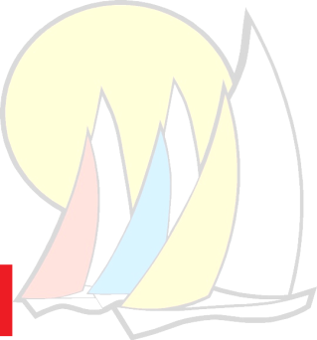**Cowpet Bay West**

**6201 Windward Way, St. Thomas, USVI 00802**

http://philpersson.name/wavy_line_2.gif

**CBW Condo Association Rules & Regulations for Tenants**

**~~to be posted inside condos~~**

**Cowpet Bay West is a residential condo community bound by the rules and regulations intended to insure neighbors’ peaceful co-existence. All visitors to our property (including short-term renters) are expected to follow our CBW property rules and regulations. Thank you.**

**USVI NOISE ORDINANCES for CONDO and BEACH:**

* **No “loud” noise-including loud talk or music-**permitted in the condos, on the balconies, nor on the beach or other outdoor spaces. **$300-$1000 fine for noise violations.**
* **USVI law defines “loud”** as “sound that can be heard 100 ft away” OR “louder than 75dBa” (the noise of a standard vacuum cleaner)

**PARKING:**

* **All owners and renters must display parking passes on their windshields.** (One owner pass and one guest pass is provided for each numbered condo unit.)
* **“Guest” spots are indicated throughout the property and should not be occupied for more than 24 hours.**
* **Unauthorized vehicles (no parking pass displayed) will be towed.** No boat, trailer, or heavy commercial vehicle is authorized to park on the property. **$100-$200 fine and possible towing for parking violations.**

**TOILETS:**

* **NOTHING besides standard toilet paper can be flushed down the toilets!!! No tampons, no “flushable” wipes- they are NOT safely flushable in a 50 year old system.**
* **Owners/renters will be billed for pipe repairs which can run to $15,000.**

**TRASH:**

* **No garbage or trash may be left nor disposed of on or adjacent to our property.**
* Owners/renters may place **BAGGED**-**household trash ONLY-no paint/construction materials**- in the designated bins at the end of Leeward and Windward.
* No trash is to be left on porches at anytime and no trash service is to be employed.-**$100-$400 fine for trash violations.**

**OUTDOOR SPACES:**

* **Barbecuing** is not permitted on seaside galleries/balconies.
* **No personal items may be placed on or stored** under stairways, railings, or entry bridges.
* **Balconies and street-side porches: No towels, laundry, etc may be hung on railings.**

**DOGS:**

* **No dogs are allowed on condo property** unless they are registered service animals.
* Service animals must be leashed, and owner/tenants must clean up after them. **$100-$400 fine.**

**Short-term renters should contact their rental agent about any issues with the rental unit, and not the Cowpet Office. Thank you.**

**“Water is a precious resource here in St. Thomas-please use it cautiously.”**